**Lesson 4 Lesson-End Project**

**Conduct a Transaction of Bitcoin Using Electrum Wallet**

|  |
| --- |
| **Project agenda:** To conduct a transaction of Bitcoins using the Electrum wallet  **Description:** You are a Blockchain expert and have been asked to download and set up the Electrum wallet to conduct a transaction of Bitcoins.  **Tools required:** Ubuntu, web browser, and Electrum wallet  **Prerequisites:** None  **Expected deliverables:**  Download and set up the Electrum software wallet, create a new wallet, and perform a transaction of Bitcoins using this wallet |

**Steps to be followed:**

1. Download and set up the Electrum software wallet
2. Create a new Electrum wallet
3. Perform a transaction of Bitcoins using the Electrum wallet

**Step 1: Download and configure the Electrum software wallet**

1. Navigate to <https://electrum.org/> and click on the **Download** link

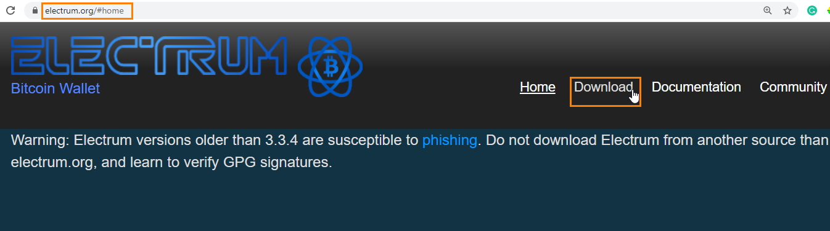

1. Click on **Appimage** in front of **Linux** to download the installer for Ubuntu

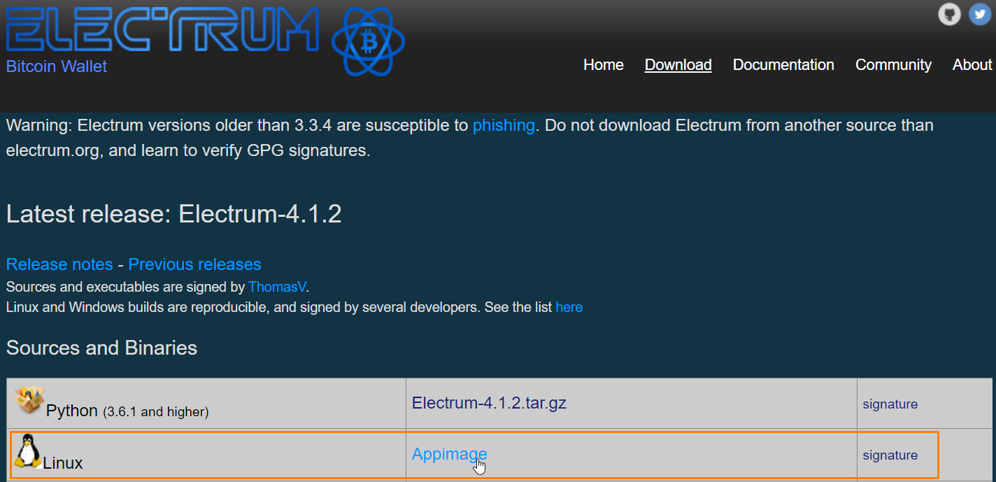

1. Go to the **Downloads** folder and right-click on **electrum-4.1.2-x86_64.AppImage** to navigate to the **Properties**

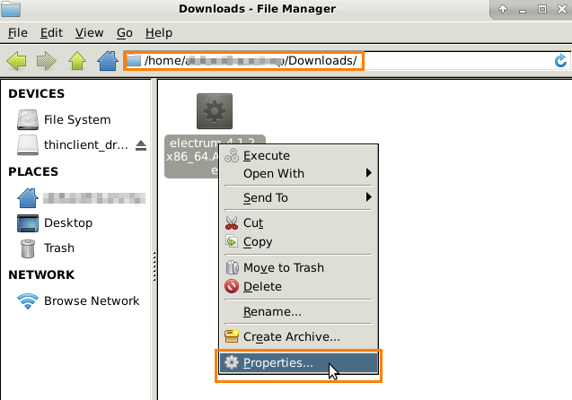

1. In Properties, go to **Permissions** and select the checkbox for **Program**

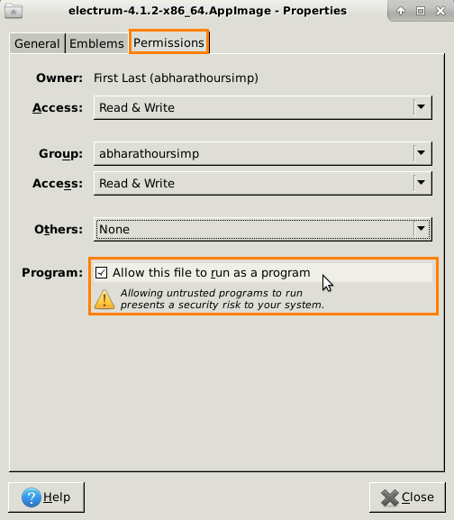

|  |
| --- |
| **Note:** This will allow the Appimage file to run as a program. |

**Step 2: Create a new Electrum wallet**

1. Double click on the **electrum-4.1.2-x86_64.AppImage** file to create a new Electrum wallet
2. On the **Install Wizard** window select the **Auto connect** option and click on the **Next** button

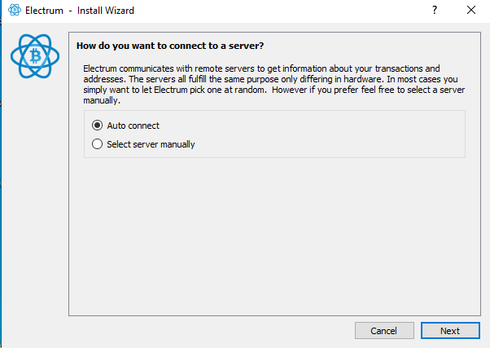

1. Enter the name of the wallet and click on the **Next** button

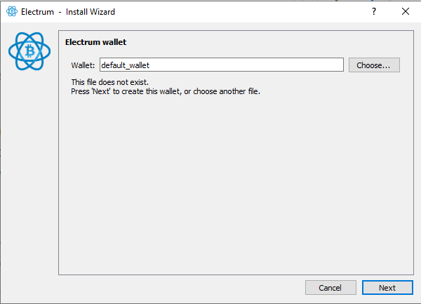

1. On the **Create new wallet** screen, select the **Standard wallet** option and click on the **Next** button

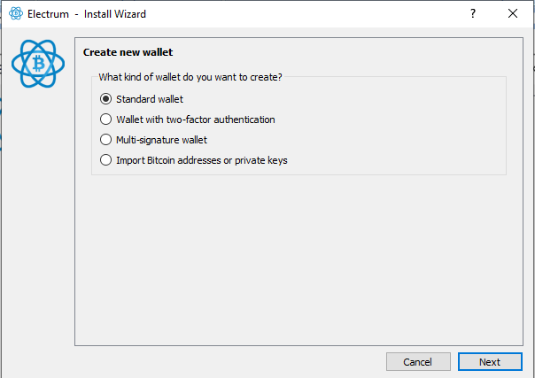

1. On the **Keystore** screen, select the **Create a new seed** option and click on the **Next** button

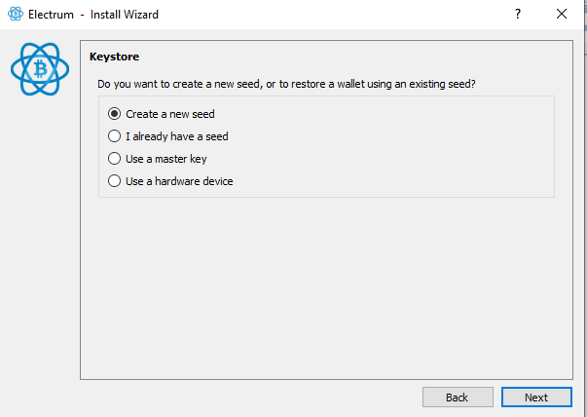

1. On the next screen, copy the **wallet generation seed** and click on the **Next** button

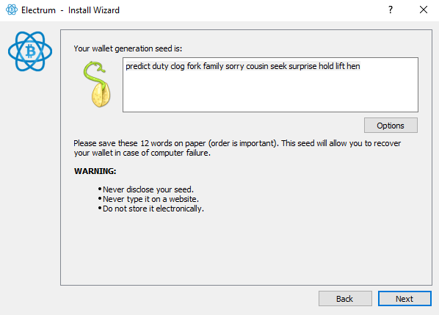

|  |
| --- |
| **Note:** This seed would be required in the next step for confirmation. |

1. On the **Confirm Seed** screen, enter the seed copied from the previous step and click on the **Next** button

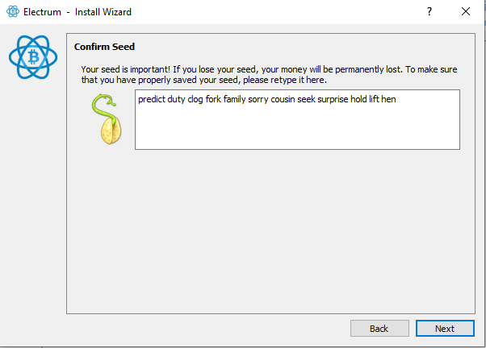

1. On thenext screen, create a password for your wallet, select the checkbox to **Encrypt wallet files**,and click on the **Next** button

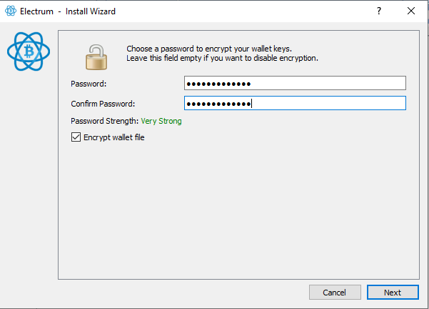

|  |
| --- |
| **Note:** This will complete your Electrum wallet creation. |

**Step 3: Perform a transaction of Bitcoins using the Electrum wallet**

1. In the Electrum wallet, navigate to the **Receive** tab and click on the **New Address** button to create a new address

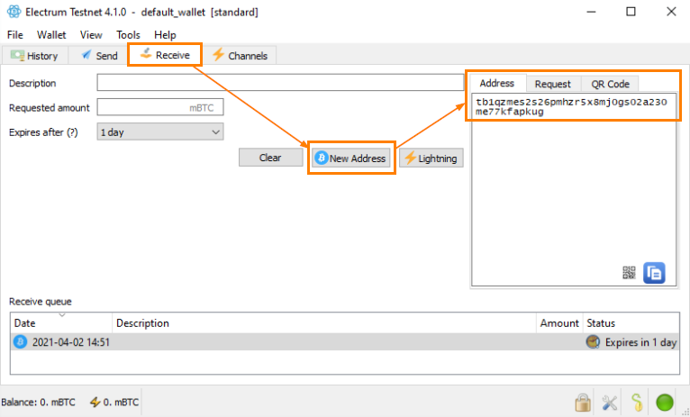

|  |
| --- |
| **Note:** Repeat this step to create another address as you need two addresses to perform a transaction. |

1. Go back to the Electrum wallet and click on the **History** tab to see the received Bitcoins

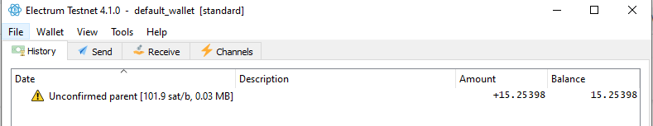

1. Go to the **Send** tab, enter the second address in the **Pay to** section, and mention the amount to be transferred in the **Amount** section. Click on the **Pay** button to transfer the amount

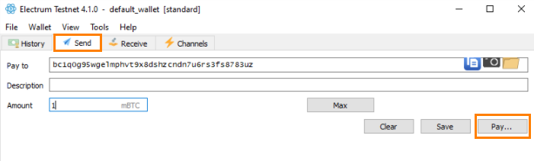

|  |
| --- |
| **Note:** Transactions can only occur if there are enough Bitcoins in an account. |

Hence the amount get transferred to receiver’s account and transaction is completed.